Workshop 1 How to Develop a Faith Plan: Early Lessons for Long-term Success

Common themes - Discussion points from the breakout rooms

The Seven Key Areas

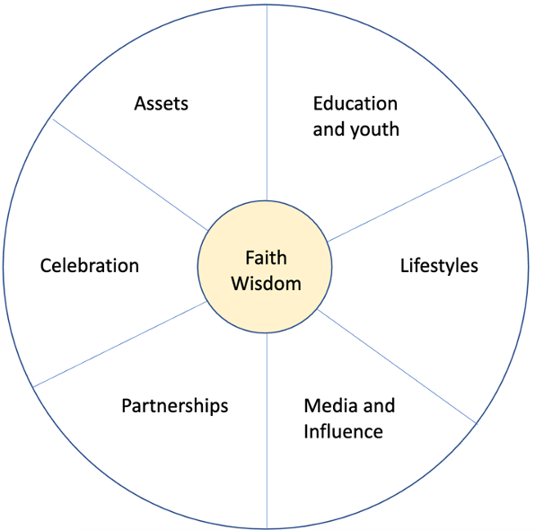

Breakout room 1

Key point: The importance of partnership. This is a much more important key area than we think! This is especially powerful when we work with those of other faith communities, expand our horizons, share stories and experience etc. which goes back to the way we have been growing, sharing and changing the world most of history! Therefore, we do not need to develop anything new, but bring together what we are already doing!

- How to start your journey? Look first at faith! This is what drives the passion. Take what our faith tells us, what we are grounded in, and use this as the building blocks for the action taken through the Plans.
- How to start your journey? Look to the community and discover what the needs are before beginning to plan! This was a well-received message after Sara spoke about it. Often a good place to start.
- How do we connect with groups and organisations that perhaps have resources to support us if we do not?
- Several smaller communities/groups raised the issue of a lack of resources and support. This makes it hard for communities to know where to begin. Often there are not enough willing people, or they are significantly lacking resources for what they aspire to do (physical, financial, human resources and time).
- It was suggested that Plan be shared so we can learn from each other. There will be a space on the website to showcase Plans soon!

Breakout room 2

Key Point: This is a global programme but also acknowledges local context and local opportunities and strengths.

- Need for unity and cohesion. This needs to be central to faith – it is not an add on. Start with your faith story and grow from there
- Develop a theology of the environment. Start with the theology that people know, that is in their hearts. Write this down, or present it to your community in a meaningful and engaging way that will help them understand the importance of creation/environmental care from a the perspective of their faith.
- Important to have the political will. Is there an opportunity to influence those in political positions?
- Importance of linking development, faith and environment.
- Integral approach from faiths can help address local needs, social justice problems, development etc. This can also be attractive to groups who may support this kind of work.
- Universality of faith plans. This programme is establishing a global network of action.
- Example: Local assembly of Bahais in Glasgow – EcoPledges. 19 EcoPledges made, each have a holy text and practical example. These are inspiring people to be a part of environmental action.
- Resource: Book ‘Faith for Earth: A Call for Action’ free to download at: https://parliamentofreligions.org/faith-earth-call-action
- For some communities and organisations, it may be difficult to have one over-arching plan, but several have set up a commission to develop and support the creation of a Faith Plan.

Breakout room 3

Key Point:

- A wonderful diversity of participants in our room! Great introductions. Two participants from EcoSikh and three from the Focolare movement.
- Normal processes are based on reduction, as Lorna said, but faiths do it differently. - a speaker from Focolare
- One participant said they found some of the process confusing. They’ve only just started last week and the diagram with the circle of wisdom with the themes around it. Her confusion is ‘where do we begin’ because you can’t cover everything. What can you address with your faith to align your actions with the wisdom of the faith and see how that feeds in to other things, such as advocacy. How does this tie in with the other six actions? How can we use that? How do you get off the ground? ‘We’re a bit nervous and unsure. Maybe it’s just me!’ Taking those first initial steps and coming to a consensus of the priorities within our faith group.
- Susie said that Eileen is not alone. There are so many possibilities that you can be dazzled by the infinite possibilities. You don’t have to do all of them.
- Lorna proposes starting by doing the audit because some groups don’t know what they have at their disposal and where you can focus and add value. Where’s the energy to focus your plan? Catherine will launch an online questionnaire as a tool to have a conversation to explore your assets and resources and look at how aligned they are with your mission to care for people and planet. How do your faith and values connect with that message of ecology? How important is [the item] to your faith?
- Ravneet said that every faith group wants to start from somewhere. He proposes starting with celebration. It’s a new way to celebrate important days from the faith, like Sikh Environment Day on 14th March: this is now being celebrated in more than 12 countries now. Many gurdwaras have made so many changes now. Celebration has played the biggest part although it started late in their work.

